**Exercise 2: E-commerce Platform Search Function**

**Output:**

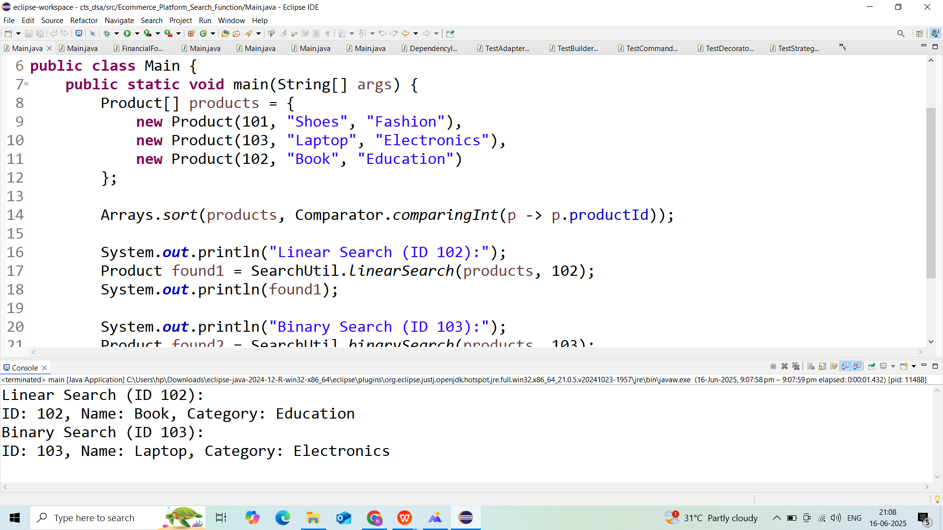

**Exercise 7: Financial Forecasting**

**Output:**

